Grammar-Set-B2
Quiz Settings
Property | Setting
Passing Score | 0%
Display Point Value | No
Randomize Questions
Year 5 Grammar Test 2 | No
Total Number of Questions | 15
Total Number of Questions to Ask | All
Display User Score | No
Display Passing Score | No
Display Pass Messages | Yes
Display Fail Messages | No
Pass Email recipient | No
Fail Email recipient | No

Questions
Year 5 Grammar Test 2
1. Which of the following correctly completes the sentence?

She usually goes home ________ six o’clock.
(Multiple Choice Question, 1 points, 1 attempt permitted)

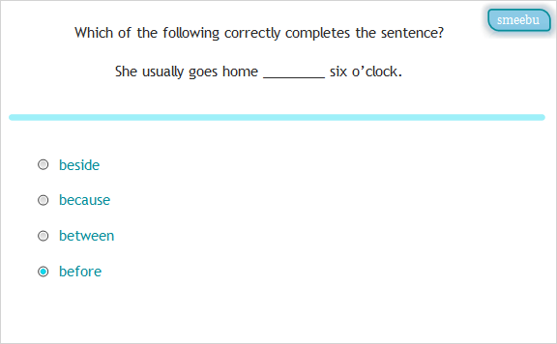

Correct | Choice
 | beside
 | because
 | between
X | before

2. Which of the following correctly completes the sentence?

It was Mike who first ________ the lion’s roar.
(Multiple Choice Question, 1 points, 1 attempt permitted)

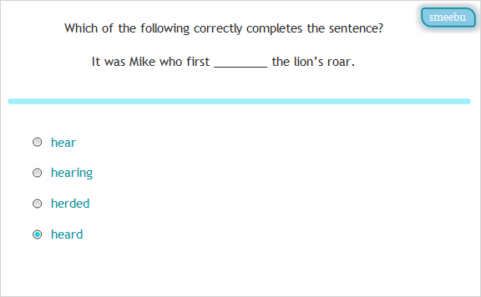

Correct | Choice
 | hear
 | hearing
 | herded
X | heard

3. Which sentence has the correct punctuation?
(Multiple Choice Question, 1 points, 1 attempt permitted)

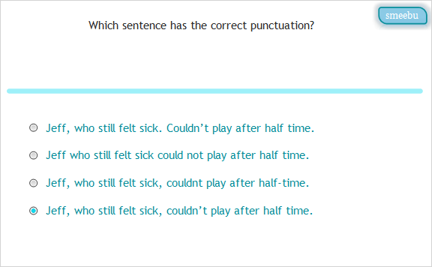

Correct | Choice
 | Jeff, who still felt sick. Couldn’t play after half time.
 | Jeff who still felt sick could not play after half time.
 | Jeff, who still felt sick, couldnt play after half-time.
X | Jeff, who still felt sick, couldn’t play after half time.

4. Which sentence is correct?
(Multiple Choice Question, 1 points, 1 attempt permitted)

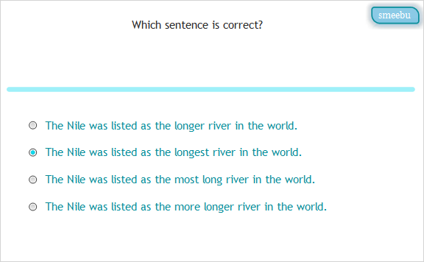

Correct | Choice
 | The Nile was listed as the longer river in the world.
X | The Nile was listed as the longest river in the world.
 | The Nile was listed as the most long river in the world.
 | The Nile was listed as the more longer river in the world.

5. Which of the following correctly completes the sentence?

The burglar alarm _______ loudly.
(Multiple Choice Question, 1 points, 1 attempt permitted)

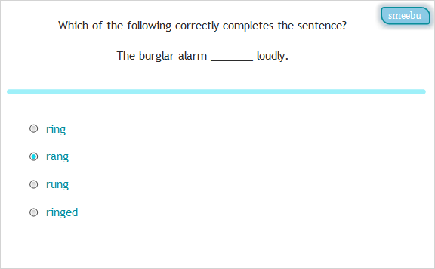

Correct | Choice
 | ring
X | rang
 | rung
 | ringed

6. Which of the following correctly completes the sentence?

The train arrived _______ than expected.
(Multiple Choice Question, 1 points, 1 attempt permitted)

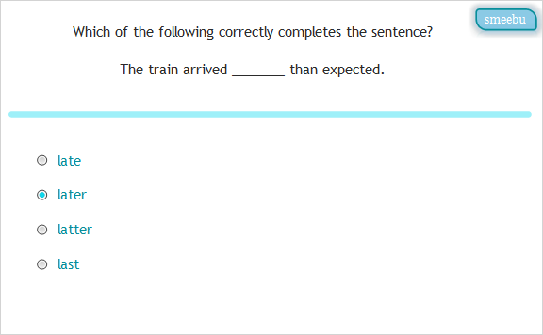

Correct | Choice
 | late
X | later
 | latter
 | last

7. Which sentence has the correct punctuation?
(Multiple Choice Question, 1 points, 1 attempt permitted)

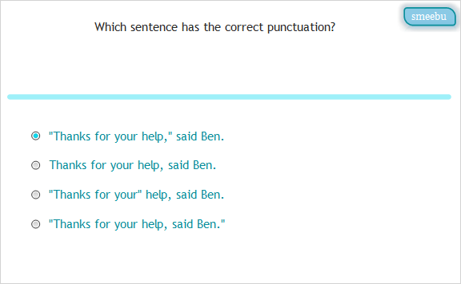

Correct | Choice
X | "Thanks for your help," said Ben.
 | Thanks for your help, said Ben.
 | "Thanks for your" help, said Ben.
 | "Thanks for your help, said Ben."

8. Which of the following correctly completes the sentence?

Jimima was ________ she would win the race.
(Multiple Choice Question, 1 points, 1 attempt permitted)

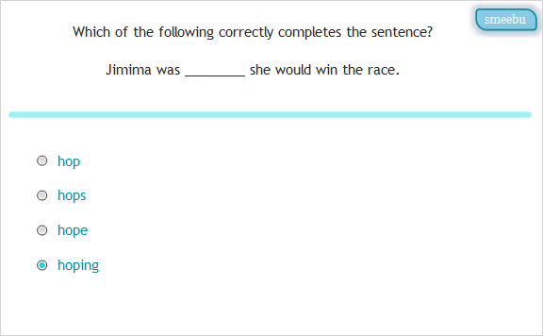

Correct | Choice
 | hop
 | hops
 | hope
X | hoping

9. Which sentence has the correct punctuation?
(Multiple Choice Question, 1 points, 1 attempt permitted)

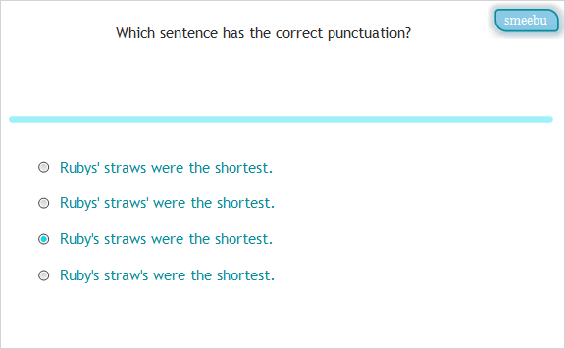

Correct | Choice
 | Rubys' straws were the shortest.
 | Rubys' straws' were the shortest.
X | Ruby's straws were the shortest.
 | Ruby's straw's were the shortest.

10. Which of the following correctly completes the sentence?

They were ________ upset about losing their money.
(Multiple Choice Question, 1 points, 1 attempt permitted)

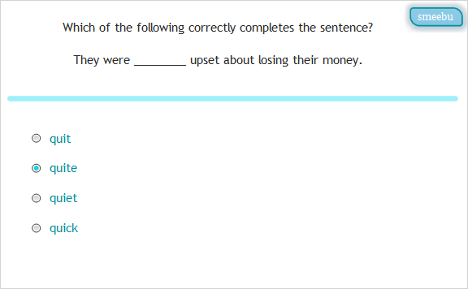

Correct | Choice
 | quit
X | quite
 | quiet
 | quick

11. Which sentence has the correct punctuation?
(Multiple Choice Question, 1 points, 1 attempt permitted)

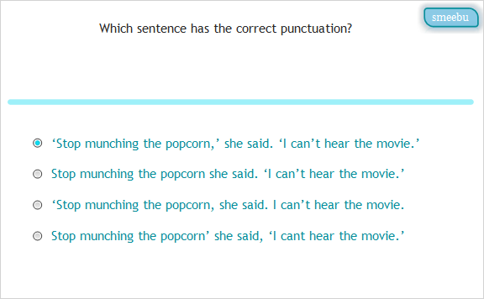

Correct | Choice
X | ‘Stop munching the popcorn,’ she said. ‘I can’t hear the movie.’
 | Stop munching the popcorn she said. ‘I can’t hear the movie.’
 | ‘Stop munching the popcorn, she said. I can’t hear the movie.
 | Stop munching the popcorn’ she said, ‘I cant hear the movie.’

12. Which sentence is correct?
(Multiple Choice Question, 1 points, 1 attempt permitted)

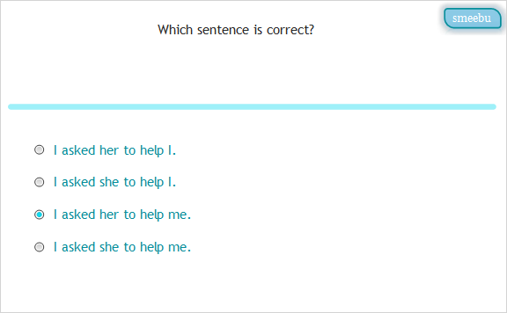

Correct | Choice
 | I asked her to help I.
 | I asked she to help I.
X | I asked her to help me.
 | I asked she to help me.

13. Which of the following correctly completes the sentence?

The two _____ of cards had some missing.
(Multiple Choice Question, 1 points, 1 attempt permitted)

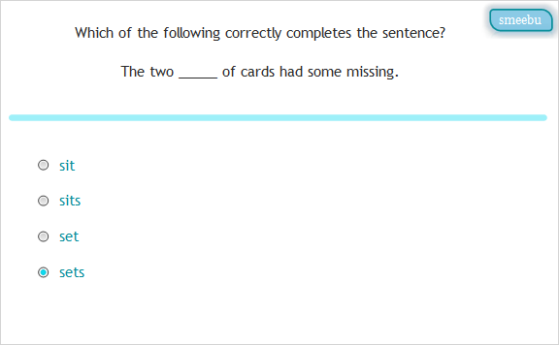

Correct | Choice
 | sit
 | sits
 | set
X | sets

14. Which of the following correctly completes the sentence?

The local shops closed __________ doors at midnight.
(Multiple Choice Question, 1 points, 1 attempt permitted)

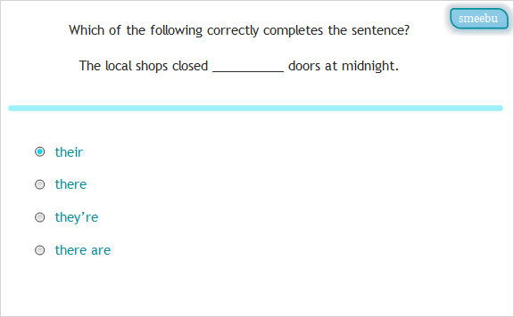

Correct | Choice
X | their
 | there
 | they’re
 | there are

15. Which of the following correctly completes the sentence?

How many students were older _______ eleven?
(Multiple Choice Question, 1 points, 1 attempt permitted)

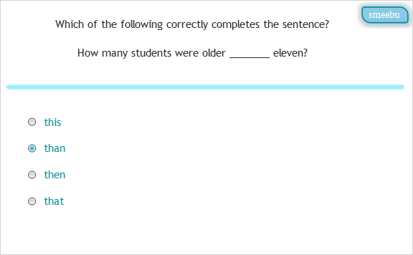

Correct | Choice
 | this
X | than
 | then
 | that

